Testing REST API Using Postman

A practical guide to GET, POST, PATCH, and DELETE operations using Postman and Supabase

Version 1.0
Jagat Jeevan Parthasarathy
May 03, 2026

Table of Contents
Introduction 3
Scope 3
Endpoint reference 3
Authentication 4
HTTP methods overview 4
Setting up Postman 5
GET method 6
Retrieving a specific student record 7
POST method 8
PATCH method 9
DELETE method 11
API response codes 13
Success codes 13
Error codes 13

Introduction
This document provides an overview of the REST API endpoints built on the Students database, created in Supabase and tested using Postman.
The API allows you to interact with the students database through standard HTTP methods — GET, POST, PATCH, and DELETE.
Use this document to learn how to use the API methods using Postman.

Scope
The Student Database used in this document was created in Supabase for testing and demonstration purposes only. The data present in the database does not represent any real student information. Postman tests and demonstrates the API requests documented in this guide.

Endpoint reference
Base URL: https://etyucsgtbmxlimthorwr.supabase.co/rest/v1/
Endpoint: students
Full endpoint URL:
https://etyucsgtbmxlimthorwr.supabase.co/rest/v1/students

Authentication
Authenticate your calls to the Student Database. Include these headers in every Postman request.
Table 1. Headers required on every Supabase API request from Postman
Key | Value | Description
apikey | <your-anon-key> | Your Supabase anon public key
Authorization | Bearer <your-anon-key> | Bearer token for authentication
Content-Type | application/json | Request format

Note:
To find your anon key, go to your Supabase Dashboard > Project Settings > API > Project API Keys and copy the anon / public key.Use the API key only through the Headers tab in Postman. Do not use it as a query parameter in the URL.

HTTP methods overview
Table 2. Supported HTTP methods and CRUD actions
Method | Action
GET | Retrieve student records
POST | Create a new student record
PATCH | Update an existing student record
DELETE | Delete a student record

Note:
The API also supports the PUT method. PUT replaces the entire record. Use PATCH when you want to update specific fields only.

Setting up Postman
- Create a new request
Select the + icon on top and select HTTP.
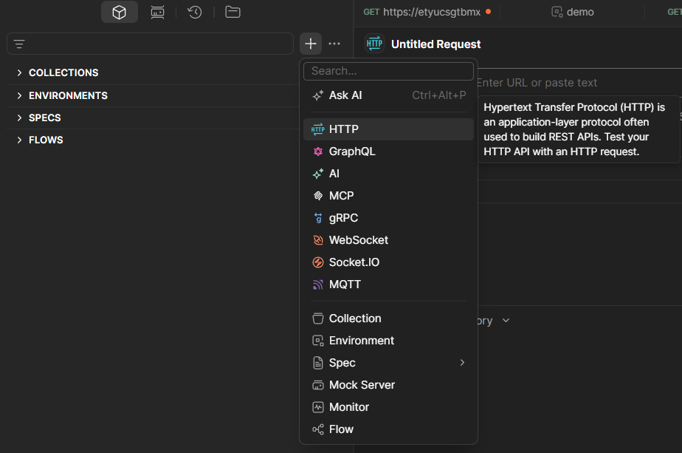Figure 1. New request type selection menu in Postman
- Select the HTTP method
At the top-left of the request panel there is a dropdown menu, it is usually set to GET by default. If you need to use POST, PATCH, or DELETE, select the dropdown and select the required method.
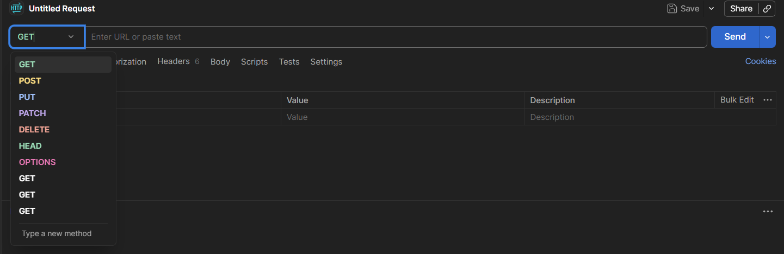
Figure 2. HTTP method dropdown showing available methods

- Enter the endpoint URL
In the URL text box, enter the full endpoint URL.
Figure 3. Endpoint URL entered in the URL text box
- Add authentication headers
Below the URL text box, select the Headers tab and enter the authentication headers as specified in the Authentication section. 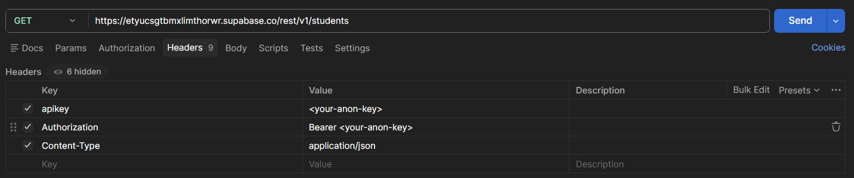
Figure 4. Authentication headers added in the Headers tab
- Select Send.

GET method
The GET method only reads data and does not modify any records. Use this method when you want to fetch student details from the database.
Endpoint: https://etyucsgtbmxlimthorwr.supabase.co/rest/v1/students
- Enter the endpoint URL in the URL text box.
- Select GET from the HTTP method dropdown.
Figure 5. GET request URL in the URL text box

- Select the Headers tab and add the required authentication headers as specified in the Authentication section.
- Select Send.
- Verify that the response shows a 200 OK status and student records in the Body tab. 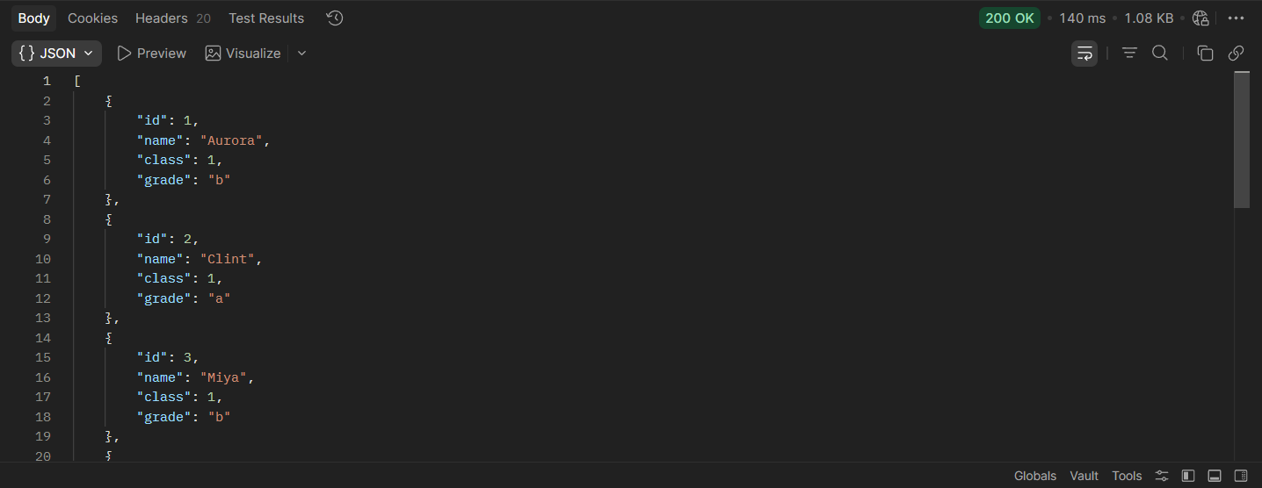
Figure 6. GET response showing 200 OK status and student records in the Body tab

Retrieving a specific student record
To retrieve a specific student information, you need to include the student ID in the URL.
Endpoint: https://etyucsgtbmxlimthorwr.supabase.co/rest/v1/students?id=eq.1
Note:
Replace 1 with the ID of the student record you want to retrieve.
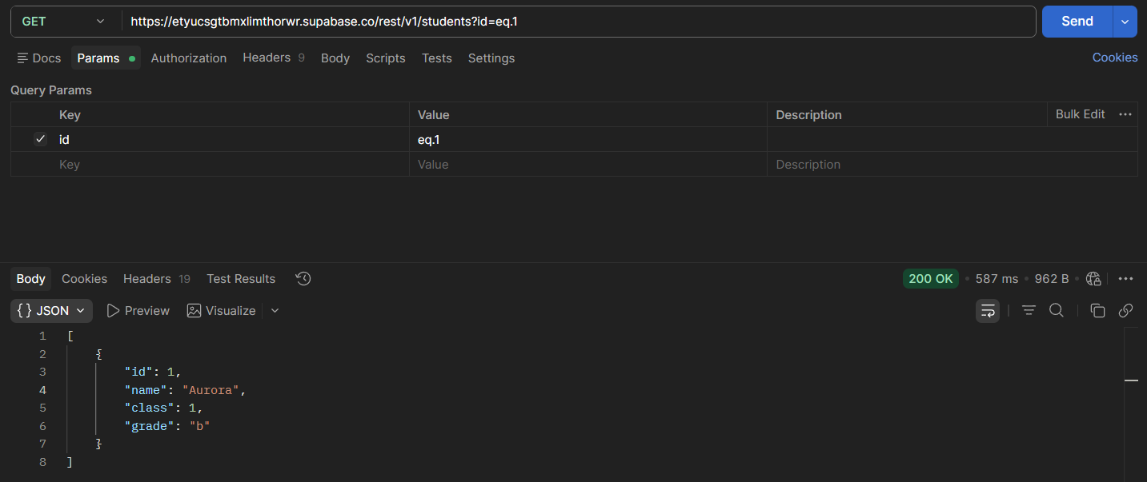
Figure 7. GET request with query parameter to retrieve a specific student record

POST method
The POST method adds a new student record. Use this method when you want to insert new student details into the database.
Endpoint: https://etyucsgtbmxlimthorwr.supabase.co/rest/v1/students
- Enter the endpoint URL in the URL text box.
- Select POST from the HTTP method dropdown.
Figure 8. POST request URL in the URL text box

- Select the Headers tab and add the required authentication headers as specified in the Authentication section.
- Add the Prefer header
Table 3. Additional header required for POST requests
Key | Value | Description
Prefer | return=representation | Returns the created record in the response

- Select the Body tab, select raw and set the format to JSON from the dropdown menu. 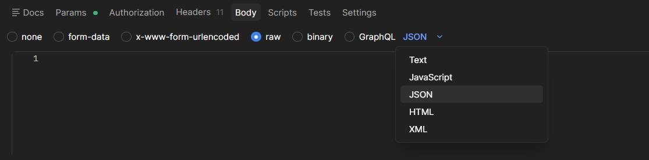
Figure 9. Body tab with raw format selected and JSON format set from the dropdown menu

- Enter the student details in JSON format. 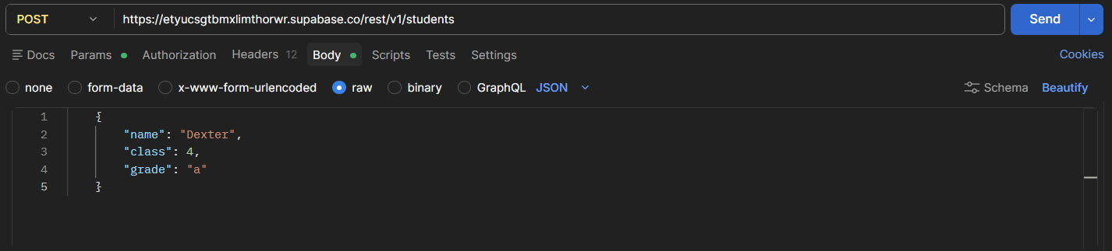
Figure 10. POST request body with new student details entered in JSON format
- Select Send.
- Verify that the response shows a 201 Created status in the Body tab. 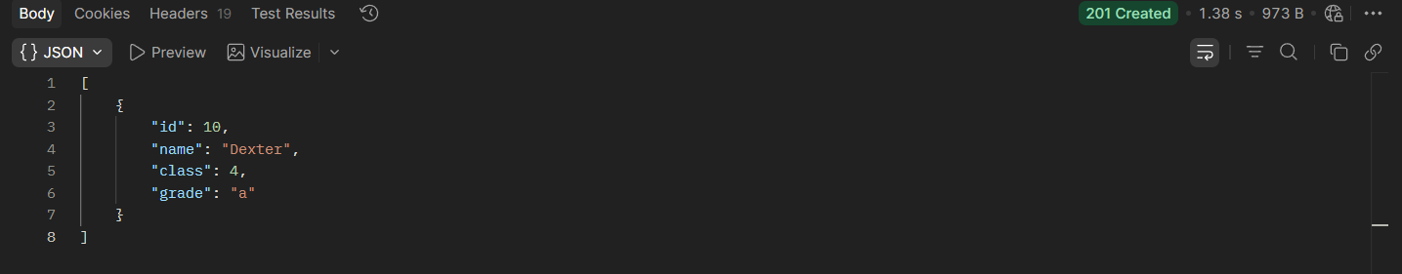
Figure 11. POST response showing 201 Created status with the new student record
Note:
The Prefer: return=representation header is optional. Without it, the API returns a 204 No Content response with no data. Including it returns the newly created record in the response with a 201 Created status. There is no need for a separate GET request to verify the record.

PATCH method
Use PATCH to update a student record without replacing the entire record. Use this method when you want to update specific fields of a student record.
Endpoint: https://etyucsgtbmxlimthorwr.supabase.co/rest/v1/students?id=eq.10
Note:
Replace 10 with the ID of the student record you want to update.
- Follow the same steps as the POST method section with the following exceptions:
  - Select PATCH from the HTTP method dropdown.
  - Enter the endpoint URL with the student ID as a query parameter. For more information, see Retrieving a specific student record in the GET method section. 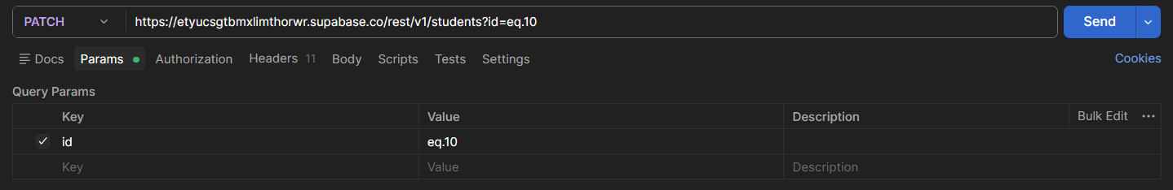
Figure 12. PATCH request with student ID query parameter in the URL text box
  - Enter only the fields you want to update in the Body tab. 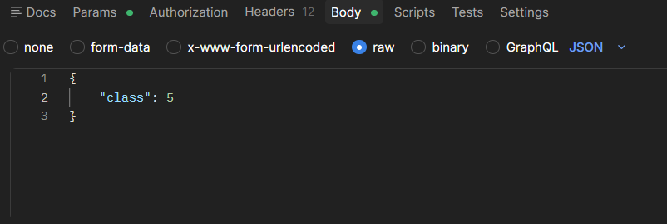
Figure 13. PATCH request Body tab with the field to update entered in JSON format

- Verify that the response shows a 200 OK status and the updated student record in the Body tab. 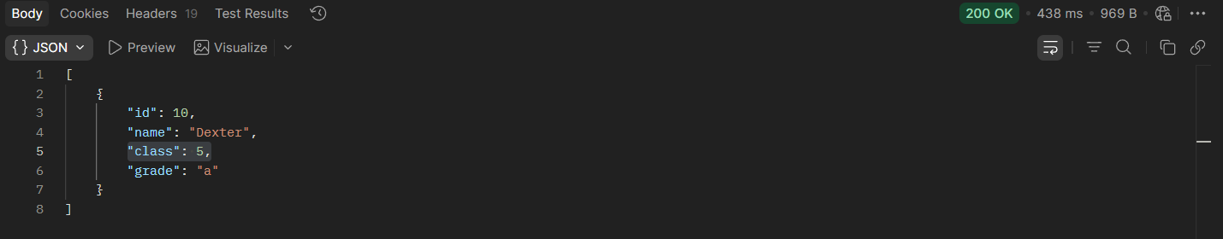
Figure 14. PATCH response showing 200 OK status with the updated student record

Note:
The response returns the complete updated record, not just the modified fields. Verify the updated values in the Body tab.

Warning:
Always include the id query parameter in the endpoint URL. Without it, the PATCH request will update all records in the students table.

DELETE method
Use DELETE to remove a student record from the students database. Use this method when you want to permanently delete a student record from the database.
Endpoint: https://etyucsgtbmxlimthorwr.supabase.co/rest/v1/students?id=eq.1
Note:
Replace 1 with the ID of the student record you want to delete.
            - Follow the same steps as the POST method section with the following exceptions:
- Select DELETE from the HTTP method dropdown.
- Enter the endpoint URL with the student ID as a query parameter. For more information, see Retrieving a specific student record in the GET method section.
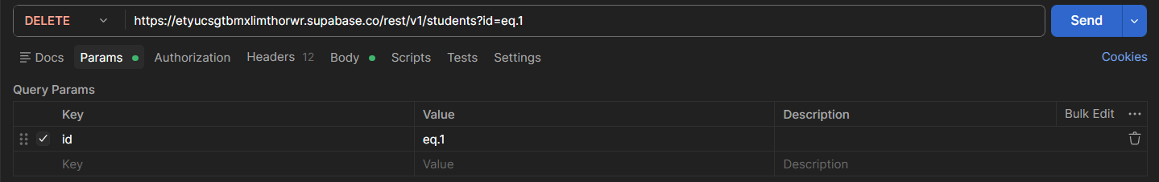
Figure 15. DELETE request with student ID query parameter in the URL text box
- The DELETE method does not require a request Body. Leave the Body tab empty.
            - Select Send.
Note:
The DELETE request can return two different status codes depending on the Prefer header:
- If the Prefer: return=representation header is included, the API returns a 200 OK status with the deleted record in the response body. 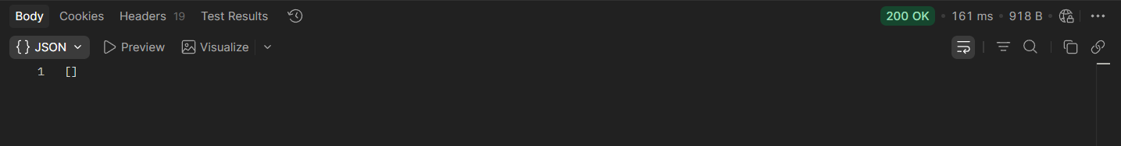
Figure 16. DELETE response showing 200 OK status when the Prefer header is included
- If the Prefer: return=representation header is excluded, the API returns a 204 No Content status with an empty response body.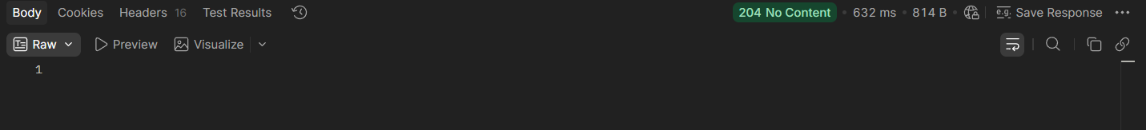
Figure 17. DELETE response showing 204 No Content status when the Prefer header is excluded

Both responses confirm that the student record has been successfully deleted.
Warning:
Always include the id query parameter in the endpoint URL. Without it, the DELETE request will permanently remove all records from the students table. This action cannot be undone.

API response codes
This section lists the HTTP status codes returned by the Student Database API. Use this section to identify and resolve errors that occur during API requests in Postman.

Success codes
Table 4. HTTP success status codes
Status Code | Method | Description
200 OK | GET, PATCH | Request was successful
201 Created | POST | Record was created successfully
204 No Content | DELETE | Record was deleted successfully

Error codes
Table 5. HTTP error status codes
Status Code | Description | Cause | Resolution
400 Bad Request | Invalid request format | Incorrect JSON body | Check the request body format
401 Unauthorized | Authentication failed | Missing or incorrect API key | Check the headers in the Authentication section
404 Not Found | Record does not exist | Wrong ID or endpoint | Check the student ID and endpoint URL
405 Method Not Allowed | HTTP method not supported | Wrong method selected | Select the correct HTTP method from the dropdown
500 Internal Server Error | Server-side error | Server error | Retry the request later

